

**Lesmurdie Senior High School**

**Semester One Examination, 2015**

**Question/Answer Booklet**

**AEBIO – Biology**

**STUDENT NAME: ______Answers__________________**

**Teacher's Name: ________________________________**

**Time allowed for this paper**

Reading time before commencing work: 10 minutes

Working time for paper: Two hours

**Materials required/recommended for this paper**

***To be provided by the supervisor***

This Question Paper-Answer Booklet/Multiple Choice Answer Sheet

***To be provided by the candidate***

Standard items: pens, pencils, eraser or correction fluid/tape, ruler, and highlighters

Special items: Approved non-graphics calculator

**Important note to candidates**

No other items may be taken into the examination room. It is **your** responsibility to ensure that you do not have any unauthorised notes or other items of a non-personal nature in the examination room. If you have any unauthorised material with you, hand it to the supervisor **before** reading any further.

**Structure of this paper**

This paper consists of three (3) sections:

|  |  |  |  |  |  |  |
| --- | --- | --- | --- | --- | --- | --- |
| SECTION | Number of questions available | Number of questions to be answered | Suggested working time (minutes) | Marks available | Percentage of exam | Mark |
| Section one: Multiple choice | 30 | 30 | 30 | 30 | 30 |  |
| Section two:  Short answer | 5 | 5 | 60 | 50 | 50 |  |
| Section three  Question I | 3 | 2 | 30 | 20 | 20 |  |
| TOTAL |  | | | | 100 |  |

**SECTION A - MULTIPLE CHOICE (30 Marks)**

Suggested time 30 minutes

1. What is the correct sequence of the levels for biological classification?

a) phylum, kingdom, class, order, genus, family, species

b) kingdom, phylum, class, order, family, genus, species

c) class, phylum, kingdom, class, order, family, species, genus

d) kingdom, phylum, class, order, family, species, genus

**Question 2 and 3 refer to the following graph.**

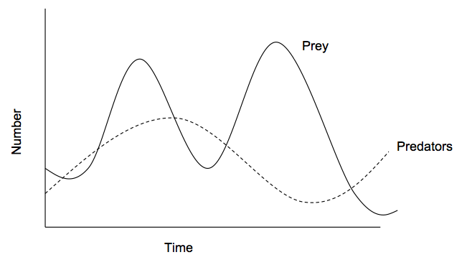

2. Which of the following statements best describes the graph above.

a) The numbers of prey in ecosystems stays constant.

b) Prey numbers in ecosystems will eventually fall to zero.

1. An increase in the numbers of predators can result in a decrease in the number of prey.

d) The number of prey and predators are not related.

3. Describe the relationship between the prey and predators in the graph.

a) Competitors

b) Predator-Prey

c) Ammensalism

d) Commensalism

4. Two wolves (*Canis Lupis)* compete for the same food source and habitat. This relationship can best be describe as:

a) Interspecific Competition

b) Intraspecific Competition

c) No competition as they are the same species.

d) Predator-Prey Competition

5. The silver gull *Larus nevaehollandiae* is an ocean-going bird that breeds on Carnac Island off the Western Australian coast near Perth. The island is also home to many tiger snakes that prey on Silver Gull eggs and nestlings (young birds). A biologist suggested that the Silver Gull population would be much larger if the tiger snakes did not eat some of the eggs and nestlings. This suggestion is:

a) a hypothesis.

b) an observation.

c) a theory.

d) a conclusion.

Biologists reasoned that if the suggestion in question 12 was correct, then silver gull nests protected from tiger snakes should produce more young than nests exposed to tiger snakes. To test this reasoning, they constructed fences around some nests that allowed the parent birds to fly in but stopped tiger snakes from crawling in. They recorded the number of eggs laid and nestlings that survived to maturity in each treatment. The results are shown below.

|  |  |  |
| --- | --- | --- |
|  | **Unfenced plot**  (tiger snakes can get in) | **Fenced plot**  (tiger snakes cannot get in) |
| Number of eggs laid | 230 | 620 |
| Number of nestlings surviving to maturity | 40 | 52 |

6. What was the control in this experiment?

a) The number of young surviving to maturity.

b) The number of eggs in the experiment.

c) The fenced plots where tiger snakes cannot get in.

d) The unfenced plots where tiger snakes can get in.

7. What was the dependent variable in the experiment?

a) The number of nestlings surviving to maturity.

b) The number of nests studied.

c) The population size of the tiger snakes.

d) The change in the population size of the silver gulls.

8. What was the independent variable in the experiment?

a) The number of tiger snakes in the population.

b) Whether or not the nests were exposed to tiger snakes.

c) The percentage of the eggs laid that hatched.

d) The number of tiger snakes to which the nestlings were exposed.

9. Food chains show the flow of:

a) chemical energy

b) heat energy

c) light energy

d) kinetic energy

10. A close relationship between two organisms in which one of the organisms benefits and the other is affected negatively.

a) mutualism

b) parasitism

c) commensalism

d) competition

11. To an ecologist, a ‘population’ is:

a) all the organisms occurring in a given area

b) the number of members of the same species per unit area at a particular time.

c) the number of organisms per unit area m2

d) all the members of the same species living in a defined area at a particular time.

**Questions 12 and 13 refer to the following graph.**

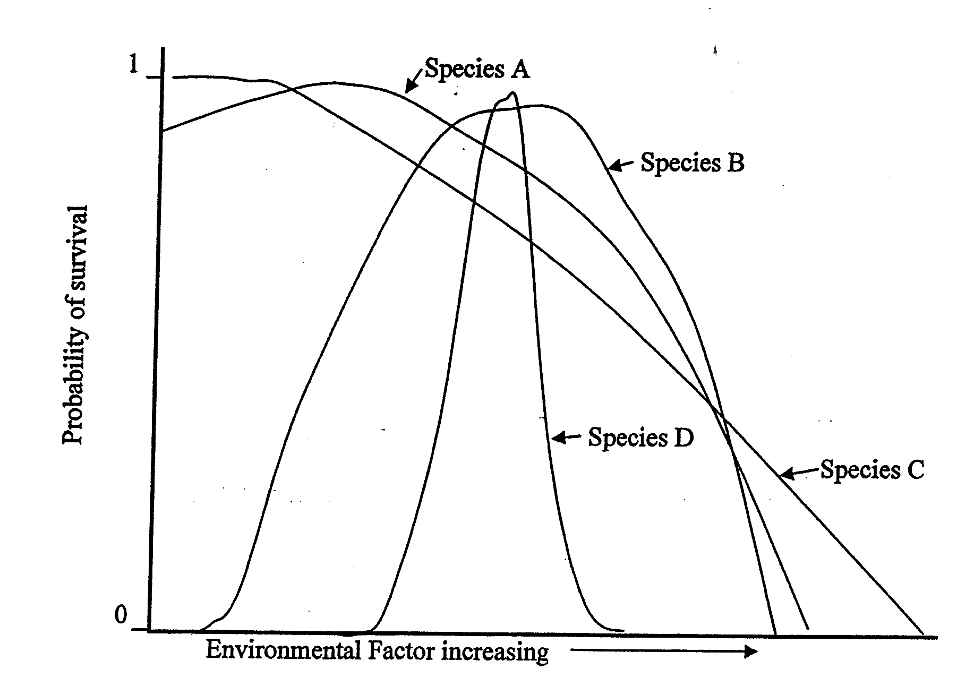

12. The species with greatest tolerance to the environment factor analysed in this graph is:

a) A

b) B

c) C

d) D

13. This graph shows that species D survives over a smaller range than the other species. This suggests that species D is :

a) highly adapted to a particular environment.

b) a parasite on a tree.

c) a saprophyte in the gut of a mammal.

d) poorly adapted to the environment.

**The next Questions 14 and 15 refer to the following graph showing how the internal body temperature of a reptile (lizard), a primitive mammal (Echidna) and an advanced mammal (cat) vary with the temperature of the environment (ambient temperature).**

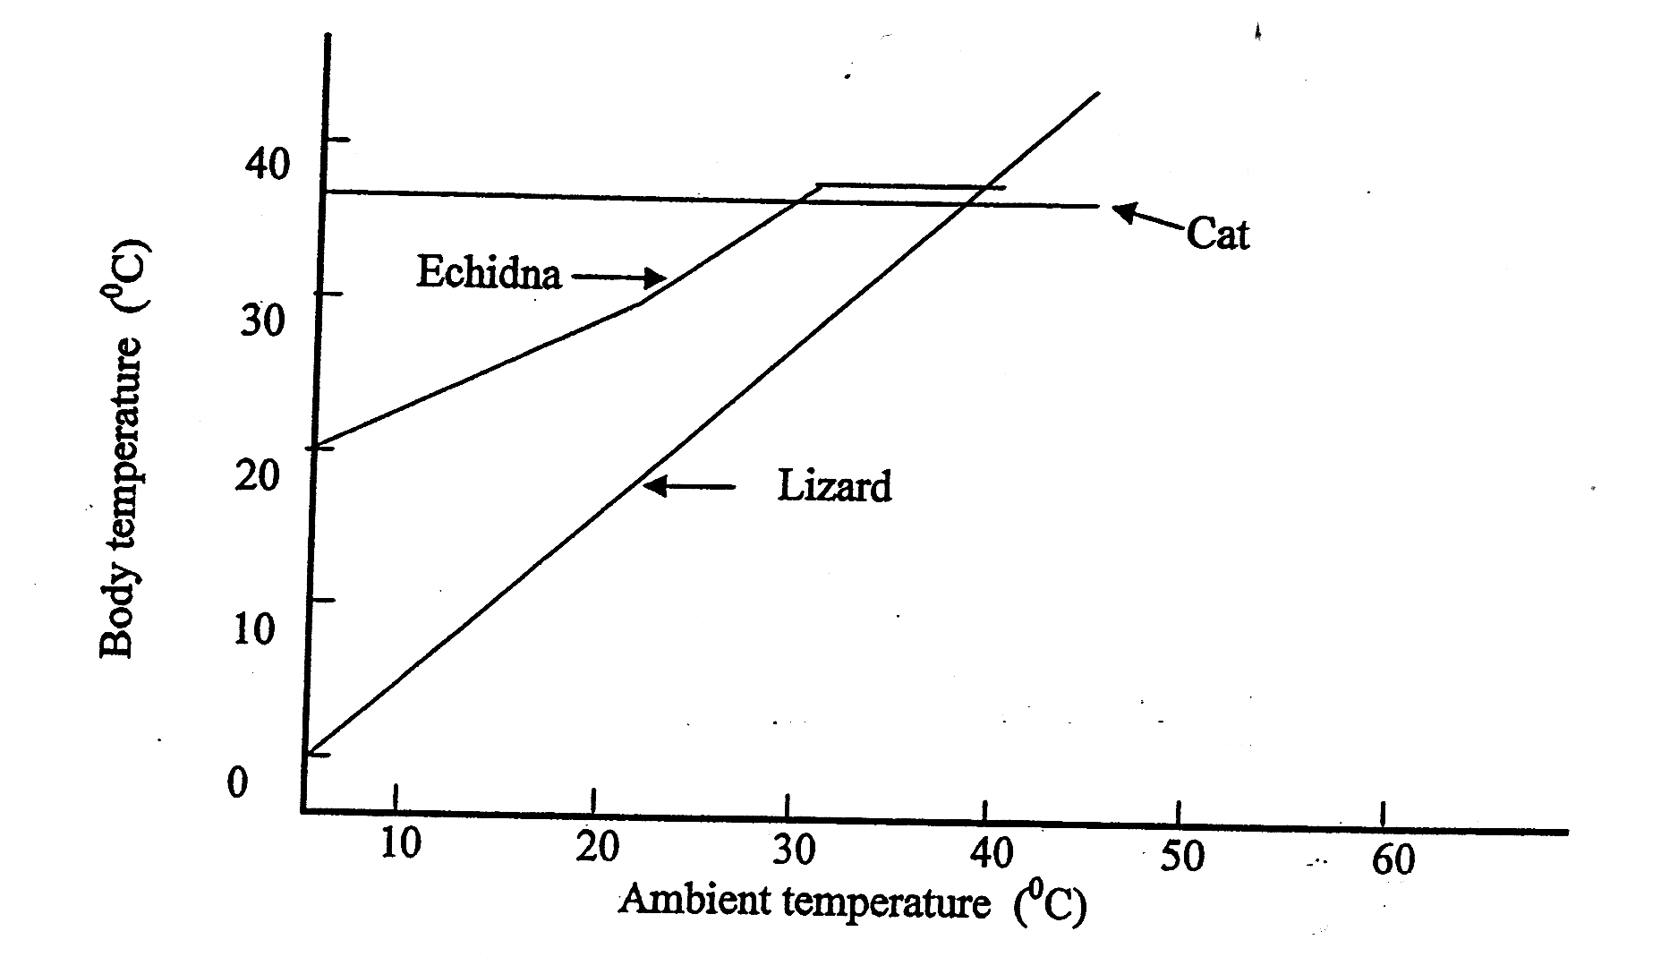

14. What is the relationship between the internal body temperature of the lizard and the temperature of the environment? The lizard’s temperature:

a) is always greater than that of the environment.

b) decreases with increasing environmental temperature.

c) increases with increasing environmental temperature.

d) is always the same as that of the environment.

15. What is the body temperature of the Echidna when the ambient temperature is 15oC?

a) 32oC

b) 15oC

c) 25oC

d) 40oC

16. Biological classification can be based on levels of similarity of molecular sequences. Haemoglobin is the iron-containing oxygen-transport protein in the red blood cells of almost all vertebrates. The human beta chain of haemoglobin contains 146 amino acid residues. Advanced technology now allows for the determination of the sequences of these amino acids in haemoglobin from various species. In the following list, the numbers represent the number of amino acid differences between the beta chain of human haemoglobin and the haemoglobins of the other species: gorilla 1, gibbon 2, dog 15, horse 25, cow 25 and mouse 27.

Choose the incorrect answer from the following.

1. Humans are more closely related to dogs than to horses.
2. The degree of similarity indicates the closeness of the evolutionary relationship.
3. Humans are more closely related to gorillas than to gibbons.

d) The larger the number listed, the closer the kinship.

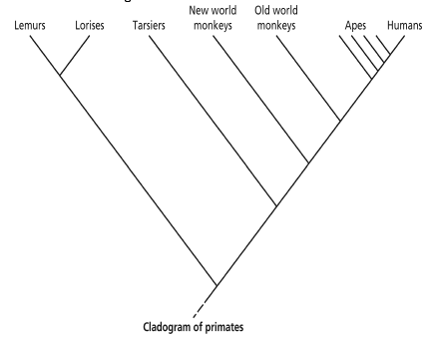17. The cladogram below shows the relationship between several primates. Choose the correct answer from the following.

1. The apes and humans are paraphyletic
2. The New World monkeys and the Old World monkeys form a monophyletic group.
3. The lorises, lemurs and tarsiers are paraphyletic.
4. The lorises and lemurs form a cladistic

18. Which of the following is not an example of mutualism?

1. Bees pollinating flowers.
2. Hermit crabs occupying empty shells.
3. Pygmy possums collecting nectar from a eucalypt
4. Mistletoe birds eating the fruit of a mistletoe plant.

19. Nitrogen moves between living organisms and the non-living world. Which of the following is an accurate description of part of this process?

1. Some bacteria are able to take in atmospheric nitrogen and fix it into a chemical form that can be used by plants for growth.
2. Compounds that contain nitrogen are poisonous to animals and are rapidly excreted into the non living environment.
3. Nitrogen is taken in from the atmosphere by green plants and used in the synthesis of important biological molecules.
4. The proportion of nitrogen in the atmosphere stays constant because biological processes do not affect it.

20. Which of the following food chains makes the most energy available to the hawk?

1. Grasses➔Mouse➔Snake➔Hawk
2. Grasses➔Insects➔Mouse➔Snake➔Hawk
3. Grasses➔Rabbit➔Hawk
4. Grasses➔Rabbit➔Snake➔Hawk

21. Which one of the pyramids below best shows the relative numbers of individuals in a food chain containing trees, caterpillars and insectivorous birds?

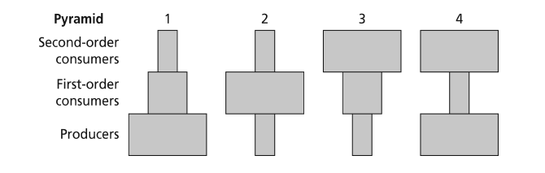

1. Pyramid 1
2. Pyramid 2
3. Pyramid 3
4. Pyramid 4

22. Choose the best description from the following. Species distribution modelling:

1. shows the movement of individuals away from centres of high population density.
2. is the studyof the distribution of biodiversity over space over time.
3. Is the manner in which a biological population is spatially arranged
4. Is an attempt to predict a species’ future needs and resource management using computer technology.

23. When a dirt road falls into disuse, annual weeds soon begin to grow on it in increasing numbers. Eventually these weeds are no longer evident, as perennial grasses overgrow the area. The biological principle best used to explain this situation is:

1. Energy pyramids
2. Ecological succession
3. Cycling of matter
4. Ecological equilibrium

24. Four organisms have the sets of requirements as set out in the table below:

|  |  |  |  |  |  |  |
| --- | --- | --- | --- | --- | --- | --- |
| **Organism** | **Organic**  **Compounds** | **CO2** | **O2** | **H2O** | **Mineral**  **ions** | **Light**  **energy** |
| I | ✓ |  | ✓ | ✓ | ✓ |  |
| II | ✓ | ✓ |  |  | ✓ | ✓ |
| III | ✓ | ✓ |  | ✓ |  |  |
| IV |  | ✓ | ✓ | ✓ | ✓ | ✓ |

Which set indicates the most complete list of the requirements of a heterotroph?

1. I
2. II
3. III
4. IV

25. A detritivore is best defined as an organism which:

1. relies upon recycled inorganic matter.
2. must live in close association with another organism.
3. obtains its nutrients from the dead remains of other organisms.
4. causes harm to another organism.

26. Despite a lack of light, fungi are often found living in cave communities. This is possible because fungi:

1. are heterotrophic.
2. require only low light levels to perform photosynthesis.
3. use chemicals other than glucose as an energy source.
4. are parasitic in nature.

27. When classifying environments it is important to identify the physical and chemical features of the soil substrate. Which of the following are not properties that determine soil type?

1. Location, depth
2. Texture, colour
3. Porosity,pH
4. Microorganism capacity

28. Members of a species found in a particular community at a particular time are known as:

1. a niche
2. a population
3. an ecosystem
4. a family

29. When succession occurs, the species present change because:

1. the early species exhaust the food supply and die out.
2. different species take different lengths of time to develop.
3. each community alters the environment, enabling other organisms to become established.
4. the change in climate from season to season creates different physical environments, suiting different species.

30. Factors which affect the rate of growth of a population (r) are birth rate (b), death rate (d), emigration (e) and immigration (i).

Which of the following must be true if (r) has a negative value?

1. (e) is greater than (i)
2. (d) is grater than (b)
3. (d) + (e) is greater than (b) + (i)
4. (i) + (e) is greater than (b) + (d)

**END OF SECTION A - MULTIPLE CHOICE**

**SECTION B – SHORT ANSWER (50 marks)  
*Suggested time: 50 minutes***

**Answer all questions in spaces provided.**

**QUESTION 31**

The following dichotomous key can be used to identify common swallows in WA.

1a Tail forked Go to 2

1b Tail with square tip Go to 3

2a Bluish black back, some red on the head. Found through

most of WA except for the Kimberlys and central desert. *Hirundo neonexa*

2b Black and white. Has a stripe on the back of head visible

from aerial view. Found throughout WA except for the

north Kimberly region. *Cheromoeca leucosternus*

3a Head predominantly reddish brown, no bar through eye.

Found throughout most of WA except for the southeast. *Hirundo ariel*

3b Head predominantly bluish, a dark bar can be seen through eye.

Found throughout most of WA except for the central desert. *Hirundo nigricans*

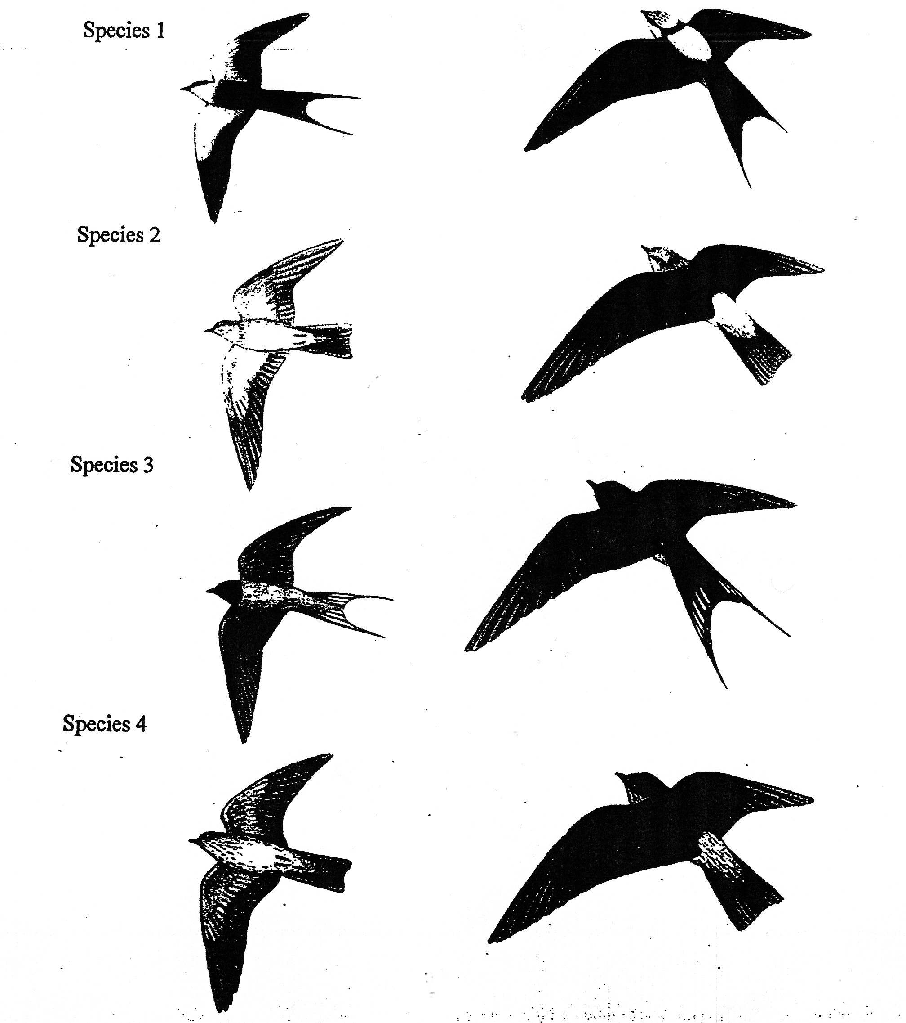

a) Which items of information used in the key are likely to be useful for formally classifying these birds? [1 mark]

_Forked or square tail, Tripe on back of head, Bar through eye. Any 2 (½ each)

b) What additional information about the birds might be useful in classifying them?

[1 mark]

Beak shape/ colour/DNA sequencing, any suitable (1mark)

c) Use the key to identify each of the species from their photographs.

[2 marks]

Species 1 __ *Cheromoeca leucosternus* _

Species 2 ___ *Hirundo nigricans* ____

Species 3 ____ *Hirundo neonexa* _

Species 4 ______ *Hirundo ariel* ___

d) A fifth species of swallow, Hirundo rustica shown below, is found throughout SE Asia and also visits the far North Kimberlys.

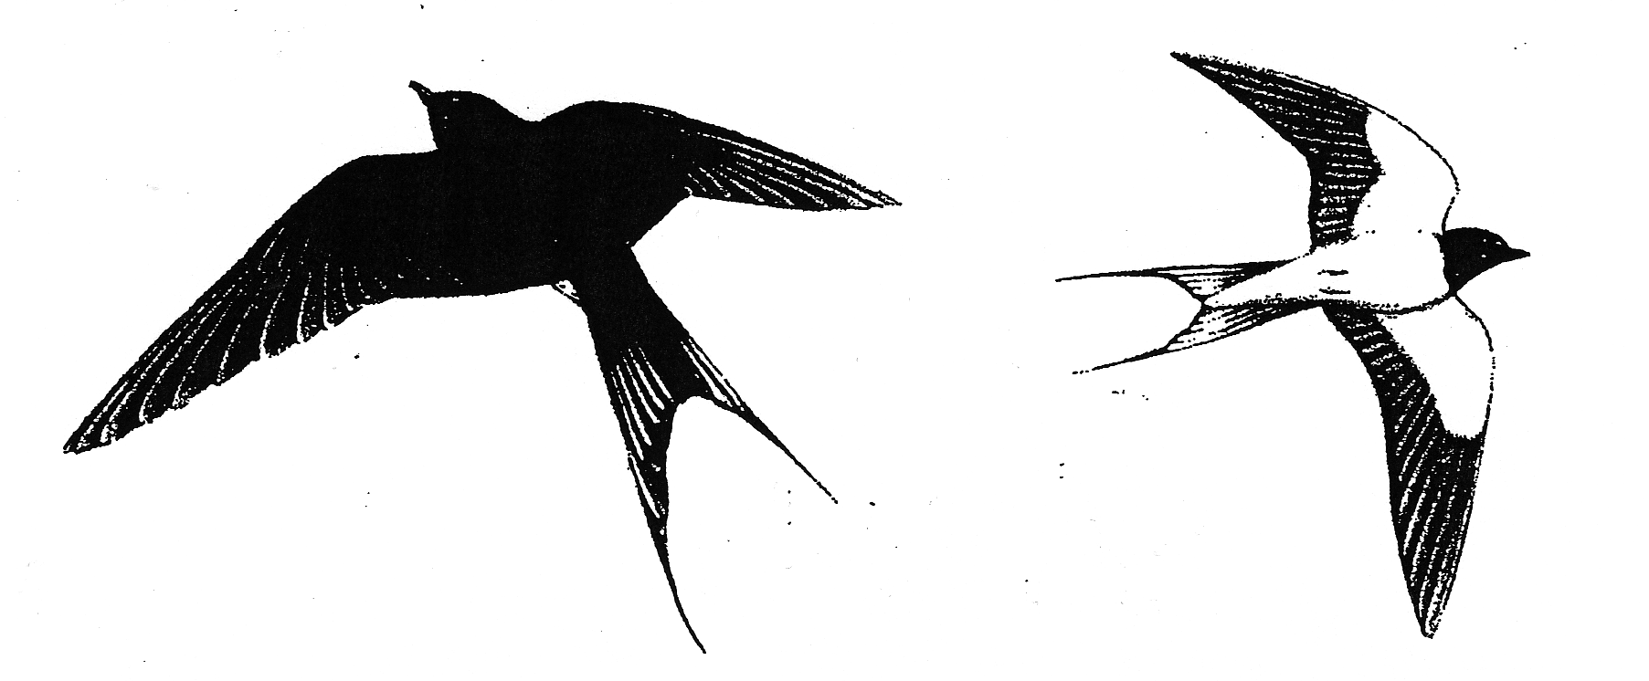

Rewrite the key on the next page to include this species. The number of rows given in the key is only a guide. Add or delete rows if you think it is necessary.

[5 marks]

|  |  |  |
| --- | --- | --- |
| 1a | Tail forked | Go to |
| 1b | Tail with square tip | Go to |
|  |  |  |
|  |
|  |
|  |
|  |  |  |
|  |
|  |
|  |
|  |  |  |
|  |
|  |
|  |
|  |  |  |
|  |
|  |
|  |
|  |  |  |
|  |
|  |
|  |
|  |  |  |
|  |
|  |
|  |

**QUESTION 32**

The diagram presented below is a representation of the carbon cycle. Use this representation to answer the questions that follow.

Atmospheric Carbon Dioxide

E

**C**

**D**

**B.**

Animals

**A.**

Fossil Fuels

Dead Remains

(a) (i) Identify the box marked A. [1 mark]

____________Producers/Plants_______________________________________________

(ii) Identify the box marked B. [1 mark]

______________________Decomposers________________________________________

(iii) Identify the process marked C. [1 mark]

_____________________________Cellular Respiration____________________________

(iv) Identify the process marked D. [1 mark]

______________________Combustion_________________________________________

(b) Explain the role of process “E” in terms of the way **carbon** enters the food chain.

[3 marks]

Photosynthesis (1 mark)

Carbon from carbon dioxide and water using the sunlight from energy is converted into glucose. (1mark)

Heterotrophs eat the producers gaining the chemical energy from the plant. (1mark)

(c) Explain the role of the organisms represented by “B” in terms of the way **carbon** is

cycled in an ecosystem**.** [2 marks]

_____B is decomposers. They feed on the the dead plants and animals and waste organic material containing carbon (1mark) and release carbon back into the atmosphere as CO2 by respiration (1mark)

The table below presents data for a freshwater lake community. This data was obtained over the course of a year. **Use this data to answer (d), (e) and (f).**

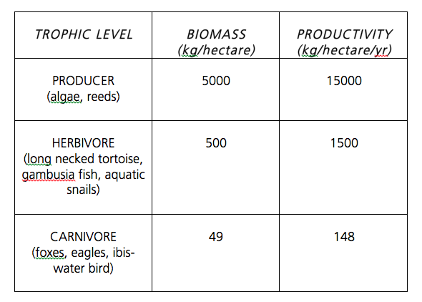

(d) Distinguish between the terms biomass and productivity and comment on the trend in these two factors over the different trophic levels.

[4 marks]

_________________________________________________________________________

_________________________________________________________________________

_________________________________________________________________________

_________________________________________________________________________

(e) (i) The productivity of the producers in the community can vary at different times of the year. State two factors that would cause the productivity of producers in this community to vary in summer compared to winter.

[2 marks]

____Hours of daylight are more in summer. Different levels of rainfall.

(ii) Select one of the factors listed above and explain how that factor causes the productivity of the producers in the community to vary in summer compared to winter. [2marks]

__More hours of daylight in summer will allow for greater levels of photosynthesis (1 mark), with more energy chemical energy now available for the plant more energy can be expended through growth therefore increasing biomass. (1mark_

(f) Using the data presented in the table, construct a biomass pyramid for this community. Your pyramid should be labelled. [3 marks]

**QUESTION 33**

A group of students conducted a field survey of the density and distribution of a small flower, Helichrysun bracteaturn, known as “everlastings”. The students used small open metal frames 1 square meter in area, as their means of sampling. Below is a diagram of their results.

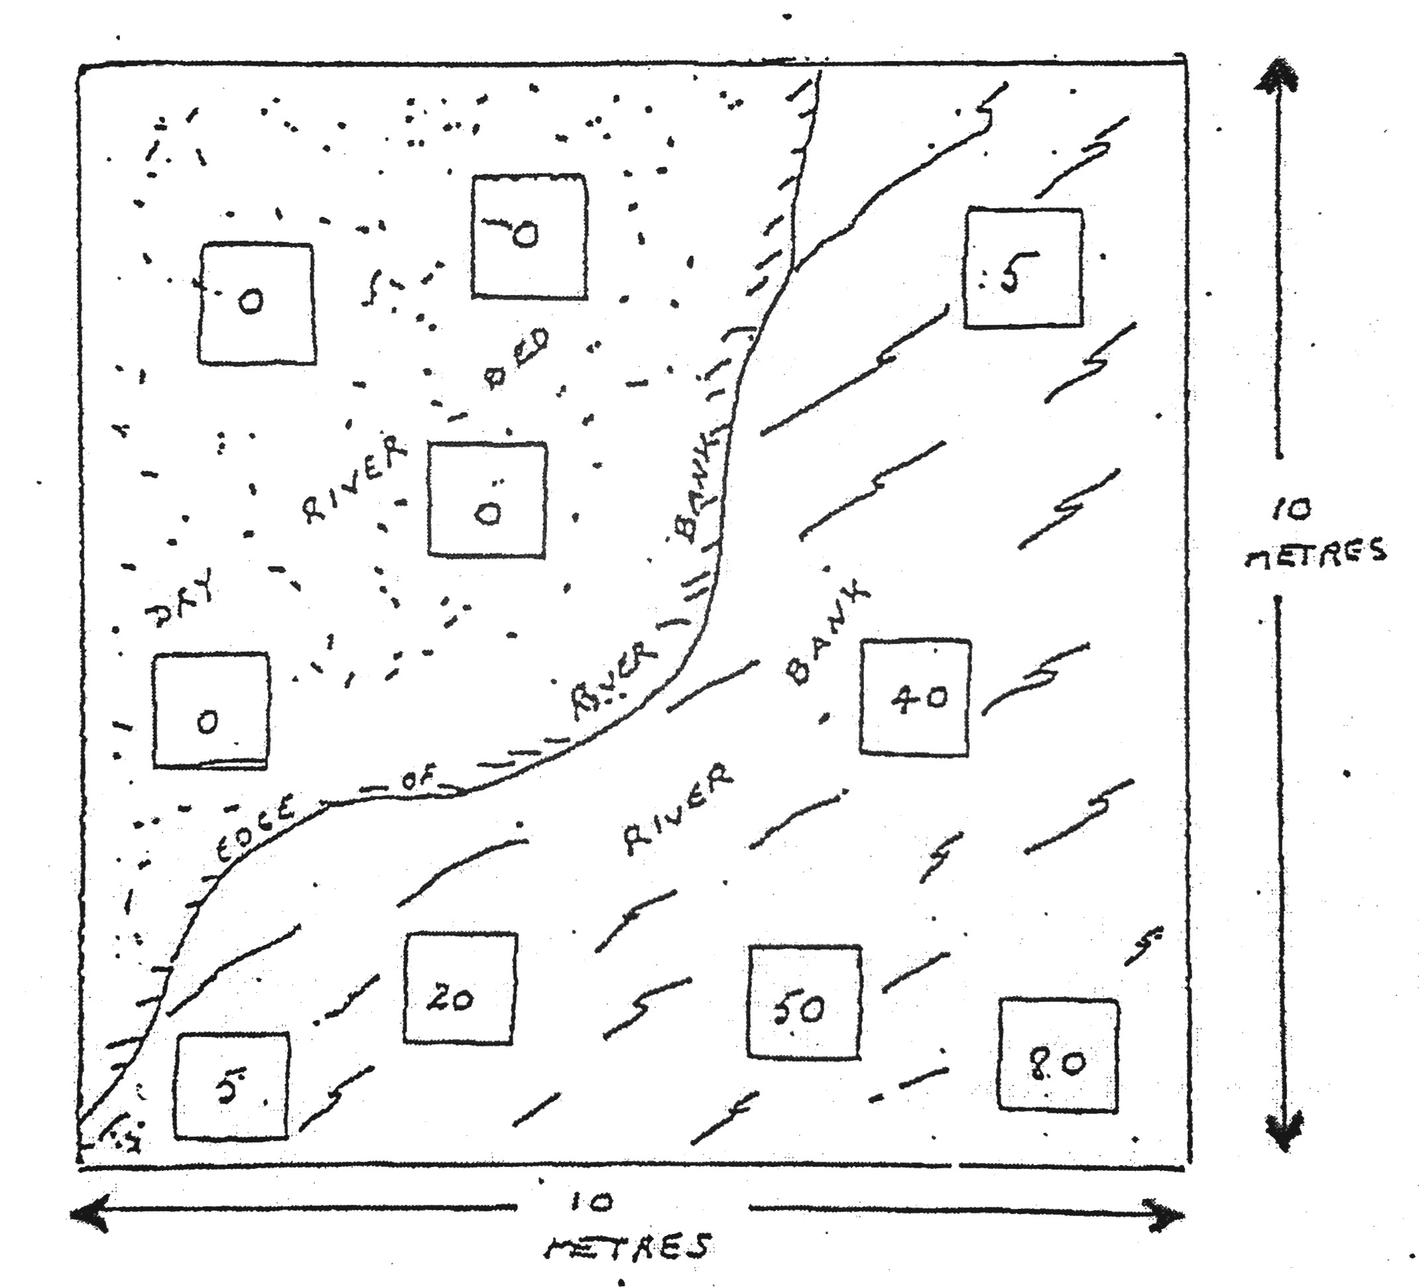

Each small square represents the site from where the sample was taken and the number of plants found in that square.

1. What name is given to the metal squares the students used in the sampling activity?

[1 mark]

____Quadrats__

1. What is the average population density of the plant in this area? Show your working. [2 marks]
2. What is the estimated population of the plant in this area? Show your working

[2 marks]

1. What is a likely way the students chose the sample sites? Why did they do this?

[2 marks]

____Random sampling. Removes/reduces the affect of bias

1. To what species do everlasts belong?

[1 marks]

­­­­­­­­ bracteaturn

**QUESTION 34**

A group of students set up a culture solution for growing yeast, and over time, estimated the population of yeast in the culture. Their results are shown below.

|  |  |  |  |  |  |  |  |  |  |  |  |  |
| --- | --- | --- | --- | --- | --- | --- | --- | --- | --- | --- | --- | --- |
| Hours | 0 | 2 | 6 | 10 | 12 | 16 | 18 | 20 | 24 | 30 | 32 | 34 |
| N0 of Yeast | 20 | 25 | 60 | 180 | 320 | 420 | 430 | 435 | 430 | 310 | 90 | 0 |

1. Graph these results

|  |  |  |  |  |  |  |  |  |  |  |  |  |  |  |  |  |  |  |  |  |  |  |  |  |  |  |  |  |  |  |  |  |  |  |  |  |  |  |  |  |  |  |  |  |
| --- | --- | --- | --- | --- | --- | --- | --- | --- | --- | --- | --- | --- | --- | --- | --- | --- | --- | --- | --- | --- | --- | --- | --- | --- | --- | --- | --- | --- | --- | --- | --- | --- | --- | --- | --- | --- | --- | --- | --- | --- | --- | --- | --- | --- |
|  |  |  |  |  |  |  |  |  |  |  |  |  |  |  |  |  |  |  |  |  |  |  |  |  |  |  |  |  |  |  |  |  |  |  |  |  |  |  |  |  |  |  |  |  |
|  |  |  |  |  |  |  |  |  |  |  |  |  |  |  |  |  |  |  |  |  |  |  |  |  |  |  |  |  |  |  |  |  |  |  |  |  |  |  |  |  |  |  |  |  |
|  |  |  |  |  |  |  |  |  |  |  |  |  |  |  |  |  |  |  |  |  |  |  |  |  |  |  |  |  |  |  |  |  |  |  |  |  |  |  |  |  |  |  |  |  |
|  |  |  |  |  |  |  |  |  |  |  |  |  |  |  |  |  |  |  |  |  |  |  |  |  |  |  |  |  |  |  |  |  |  |  |  |  |  |  |  |  |  |  |  |  |
|  |  |  |  |  |  |  |  |  |  |  |  |  |  |  |  |  |  |  |  |  |  |  |  |  |  |  |  |  |  |  |  |  |  |  |  |  |  |  |  |  |  |  |  |  |
|  |  |  |  |  |  |  |  |  |  |  |  |  |  |  |  |  |  |  |  |  |  |  |  |  |  |  |  |  |  |  |  |  |  |  |  |  |  |  |  |  |  |  |  |  |
|  |  |  |  |  |  |  |  |  |  |  |  |  |  |  |  |  |  |  |  |  |  |  |  |  |  |  |  |  |  |  |  |  |  |  |  |  |  |  |  |  |  |  |  |  |
|  |  |  |  |  |  |  |  |  |  |  |  |  |  |  |  |  |  |  |  |  |  |  |  |  |  |  |  |  |  |  |  |  |  |  |  |  |  |  |  |  |  |  |  |  |
|  |  |  |  |  |  |  |  |  |  |  |  |  |  |  |  |  |  |  |  |  |  |  |  |  |  |  |  |  |  |  |  |  |  |  |  |  |  |  |  |  |  |  |  |  |
|  |  |  |  |  |  |  |  |  |  |  |  |  |  |  |  |  |  |  |  |  |  |  |  |  |  |  |  |  |  |  |  |  |  |  |  |  |  |  |  |  |  |  |  |  |
|  |  |  |  |  |  |  |  |  |  |  |  |  |  |  |  |  |  |  |  |  |  |  |  |  |  |  |  |  |  |  |  |  |  |  |  |  |  |  |  |  |  |  |  |  |
|  |  |  |  |  |  |  |  |  |  |  |  |  |  |  |  |  |  |  |  |  |  |  |  |  |  |  |  |  |  |  |  |  |  |  |  |  |  |  |  |  |  |  |  |  |
|  |  |  |  |  |  |  |  |  |  |  |  |  |  |  |  |  |  |  |  |  |  |  |  |  |  |  |  |  |  |  |  |  |  |  |  |  |  |  |  |  |  |  |  |  |
|  |  |  |  |  |  |  |  |  |  |  |  |  |  |  |  |  |  |  |  |  |  |  |  |  |  |  |  |  |  |  |  |  |  |  |  |  |  |  |  |  |  |  |  |  |
|  |  |  |  |  |  |  |  |  |  |  |  |  |  |  |  |  |  |  |  |  |  |  |  |  |  |  |  |  |  |  |  |  |  |  |  |  |  |  |  |  |  |  |  |  |
|  |  |  |  |  |  |  |  |  |  |  |  |  |  |  |  |  |  |  |  |  |  |  |  |  |  |  |  |  |  |  |  |  |  |  |  |  |  |  |  |  |  |  |  |  |
|  |  |  |  |  |  |  |  |  |  |  |  |  |  |  |  |  |  |  |  |  |  |  |  |  |  |  |  |  |  |  |  |  |  |  |  |  |  |  |  |  |  |  |  |  |
|  |  |  |  |  |  |  |  |  |  |  |  |  |  |  |  |  |  |  |  |  |  |  |  |  |  |  |  |  |  |  |  |  |  |  |  |  |  |  |  |  |  |  |  |  |
|  |  |  |  |  |  |  |  |  |  |  |  |  |  |  |  |  |  |  |  |  |  |  |  |  |  |  |  |  |  |  |  |  |  |  |  |  |  |  |  |  |  |  |  |  |
|  |  |  |  |  |  |  |  |  |  |  |  |  |  |  |  |  |  |  |  |  |  |  |  |  |  |  |  |  |  |  |  |  |  |  |  |  |  |  |  |  |  |  |  |  |
|  |  |  |  |  |  |  |  |  |  |  |  |  |  |  |  |  |  |  |  |  |  |  |  |  |  |  |  |  |  |  |  |  |  |  |  |  |  |  |  |  |  |  |  |  |
|  |  |  |  |  |  |  |  |  |  |  |  |  |  |  |  |  |  |  |  |  |  |  |  |  |  |  |  |  |  |  |  |  |  |  |  |  |  |  |  |  |  |  |  |  |
|  |  |  |  |  |  |  |  |  |  |  |  |  |  |  |  |  |  |  |  |  |  |  |  |  |  |  |  |  |  |  |  |  |  |  |  |  |  |  |  |  |  |  |  |  |
|  |  |  |  |  |  |  |  |  |  |  |  |  |  |  |  |  |  |  |  |  |  |  |  |  |  |  |  |  |  |  |  |  |  |  |  |  |  |  |  |  |  |  |  |  |
|  |  |  |  |  |  |  |  |  |  |  |  |  |  |  |  |  |  |  |  |  |  |  |  |  |  |  |  |  |  |  |  |  |  |  |  |  |  |  |  |  |  |  |  |  |
|  |  |  |  |  |  |  |  |  |  |  |  |  |  |  |  |  |  |  |  |  |  |  |  |  |  |  |  |  |  |  |  |  |  |  |  |  |  |  |  |  |  |  |  |  |
|  |  |  |  |  |  |  |  |  |  |  |  |  |  |  |  |  |  |  |  |  |  |  |  |  |  |  |  |  |  |  |  |  |  |  |  |  |  |  |  |  |  |  |  |  |
|  |  |  |  |  |  |  |  |  |  |  |  |  |  |  |  |  |  |  |  |  |  |  |  |  |  |  |  |  |  |  |  |  |  |  |  |  |  |  |  |  |  |  |  |  |
|  |  |  |  |  |  |  |  |  |  |  |  |  |  |  |  |  |  |  |  |  |  |  |  |  |  |  |  |  |  |  |  |  |  |  |  |  |  |  |  |  |  |  |  |  |
|  |  |  |  |  |  |  |  |  |  |  |  |  |  |  |  |  |  |  |  |  |  |  |  |  |  |  |  |  |  |  |  |  |  |  |  |  |  |  |  |  |  |  |  |  |
|  |  |  |  |  |  |  |  |  |  |  |  |  |  |  |  |  |  |  |  |  |  |  |  |  |  |  |  |  |  |  |  |  |  |  |  |  |  |  |  |  |  |  |  |  |
|  |  |  |  |  |  |  |  |  |  |  |  |  |  |  |  |  |  |  |  |  |  |  |  |  |  |  |  |  |  |  |  |  |  |  |  |  |  |  |  |  |  |  |  |  |
|  |  |  |  |  |  |  |  |  |  |  |  |  |  |  |  |  |  |  |  |  |  |  |  |  |  |  |  |  |  |  |  |  |  |  |  |  |  |  |  |  |  |  |  |  |
|  |  |  |  |  |  |  |  |  |  |  |  |  |  |  |  |  |  |  |  |  |  |  |  |  |  |  |  |  |  |  |  |  |  |  |  |  |  |  |  |  |  |  |  |  |
|  |  |  |  |  |  |  |  |  |  |  |  |  |  |  |  |  |  |  |  |  |  |  |  |  |  |  |  |  |  |  |  |  |  |  |  |  |  |  |  |  |  |  |  |  |
|  |  |  |  |  |  |  |  |  |  |  |  |  |  |  |  |  |  |  |  |  |  |  |  |  |  |  |  |  |  |  |  |  |  |  |  |  |  |  |  |  |  |  |  |  |
|  |  |  |  |  |  |  |  |  |  |  |  |  |  |  |  |  |  |  |  |  |  |  |  |  |  |  |  |  |  |  |  |  |  |  |  |  |  |  |  |  |  |  |  |  |
|  |  |  |  |  |  |  |  |  |  |  |  |  |  |  |  |  |  |  |  |  |  |  |  |  |  |  |  |  |  |  |  |  |  |  |  |  |  |  |  |  |  |  |  |  |
|  |  |  |  |  |  |  |  |  |  |  |  |  |  |  |  |  |  |  |  |  |  |  |  |  |  |  |  |  |  |  |  |  |  |  |  |  |  |  |  |  |  |  |  |  |
|  |  |  |  |  |  |  |  |  |  |  |  |  |  |  |  |  |  |  |  |  |  |  |  |  |  |  |  |  |  |  |  |  |  |  |  |  |  |  |  |  |  |  |  |  |
|  |  |  |  |  |  |  |  |  |  |  |  |  |  |  |  |  |  |  |  |  |  |  |  |  |  |  |  |  |  |  |  |  |  |  |  |  |  |  |  |  |  |  |  |  |
|  |  |  |  |  |  |  |  |  |  |  |  |  |  |  |  |  |  |  |  |  |  |  |  |  |  |  |  |  |  |  |  |  |  |  |  |  |  |  |  |  |  |  |  |  |
|  |  |  |  |  |  |  |  |  |  |  |  |  |  |  |  |  |  |  |  |  |  |  |  |  |  |  |  |  |  |  |  |  |  |  |  |  |  |  |  |  |  |  |  |  |
|  |  |  |  |  |  |  |  |  |  |  |  |  |  |  |  |  |  |  |  |  |  |  |  |  |  |  |  |  |  |  |  |  |  |  |  |  |  |  |  |  |  |  |  |  |
|  |  |  |  |  |  |  |  |  |  |  |  |  |  |  |  |  |  |  |  |  |  |  |  |  |  |  |  |  |  |  |  |  |  |  |  |  |  |  |  |  |  |  |  |  |

1. Predict the population at 27 hours

[1 mark]

_____________________________________________________________________

1. After how many hours was the population 200

[2 marks]

_____________________________________________________________________

1. One student looked at the results and suggested that the population would have dropped to 0 before 34 hours. Do you agree? Explain.

[2 marks]

_____________________________________________________________________

_____________________________________________________________________

_____________________________________________________________________

1. Suggest two reasons why the population began to decline after 20 hours

[2 marks]

_____________________________________________________________________

_____________________________________________________________________

1. Is this experiment an example of an open or closed population. Explain

­[2 marks]

_____________________________________________________________________

_____________________________________________________________________

_____________________________________________________________________

1. Would you describe this yeast culture as an R-selected species or a K-selected species? Why?

[2 marks]

_____________________________________________________________________

_____________________________________________________________________

_____________________________________________________________________

**END OF SECTION B**

**SECTION C - EXTENDED ANSWERS (20 marks)**

***Suggested time: 40 minutes***

You must answer **TWO** questions (completely) out of Questions 36, 37 and 38.

Write each answer on a separate sheet of paper in your **extended answer booklet**

**Question 36**

Outline the processes of biological succession. Explain how bare uninhabited locations can develop over time into more diverse ecosystems. Briefly explain the role natural disturbances have in this process.

[10 marks]

**Primary succession starts with bare uninhabited land**

**Nudation is the development of bare uninhabited land**

**Nudation is caused by catastrophic events such as volcanic eruptions cyclones, tsunamis, earthquakes**

**Pioneer plants/ pioneer species begin to populate**

**Early colonisers usually r selected species**

**Each new community alters the environment making it more favourable**

**New species colonise and outcompete older communities.**

**Each community develops the soil**

**The end of succession is marked by a climax community.**

**Climax communities are usually k selected**

**Natural disturbances eg fire flooding, logging land clearance can lead to secondary succession.**

**This provides the opportunity for new colonisers.**

**This can lead to reestablishment of same climax community**

**Succession as a result may divert down a different succession path.**

**Question 37**

The ‘capture-recapture’ method of monitoring animals is effective to obtaining certain information about populations.

a) Explain when this process is best used and why. [2 marks]

* **Best used for mobile species 1 mark**
* **Stationary sampling eg quadrats and transects may result in incorrect estimations of population as same organism may be sampled twice.**
* **Allows an estimation of a population that cant feasibly be all counted.**

**Any two 1 mark each**

b) Explain what information can and can not be obtained with [2 marks]

this method.

* **This method does not give any indication of distribution**
* **Age distribution**
* **Gender ratios**

**Any two 1 mark each**

c) Explain the steps required to carry out this process. Be sure to include any major calculations required. [6 marks]

* + - * **captured animals are caught randomly**
* **In a way that doesn’t harm them**
* **caught animals are marked or tagged**
* **In a way that doesn’t affect them eg not obvious to predators**
* **animals are returned to their habitat**
* **recapture- a random sample is taken and the number of marked individuals counted**
* **total pop= no. marked in first sample x total number recaptured ÷ no. of recaptured animals that are marked**

**Question 38**

Explain the Five Kingdom Classification System and where it fits into the overall scheme of the classification of living things. Describe the sorts of characteristics scientists use to place organisms into the five kingdoms, using as many examples as possible. What is the future of this system and how will it change with the development of new technologies?

* **Kingdom is the first or second division of life in the formal classification system**
* **There are five kingdoms- Animals, plants, Protista, fungi and bacteria**
* **Plants have cell walls containing cellulose and obtain energy from the sun by photosynthesis**
* **Fungi are characterised by having cell walls made of chitin**
* **Protista are single celled and live in aqueous environments**
* **Animalia contains all animals including some single celled organisms**
* **Bacteria are single celled with no membrane bound organelles**
* **Living things are grouped based on similarities in** 
  + **Physical characteristics**
  + **Reproductive methods**
  + **Molecular sequences DNA, RNA, amino acid sequences**

**1 mark each**

[10 marks]

**END OF EXAM**